**PERIOD 25: THEME 2: TEENAGERS-Lesson 1**

**I. NEW WORDS**

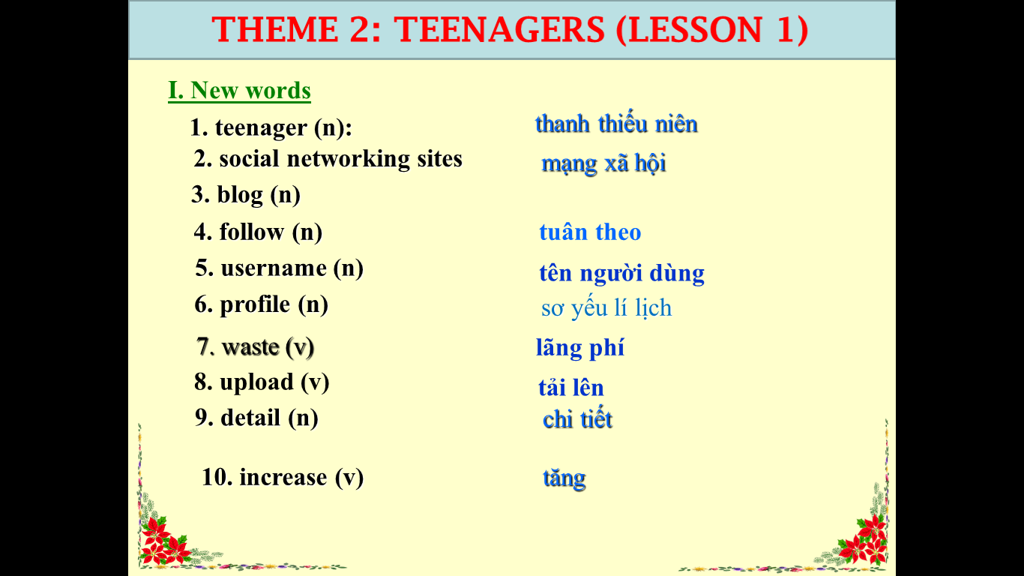

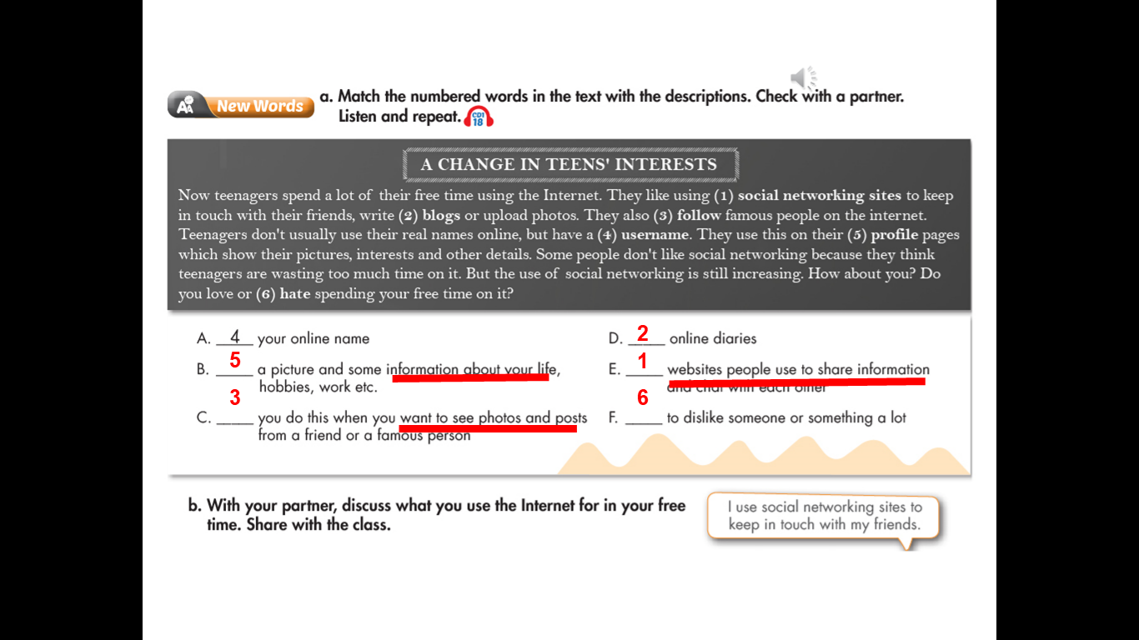

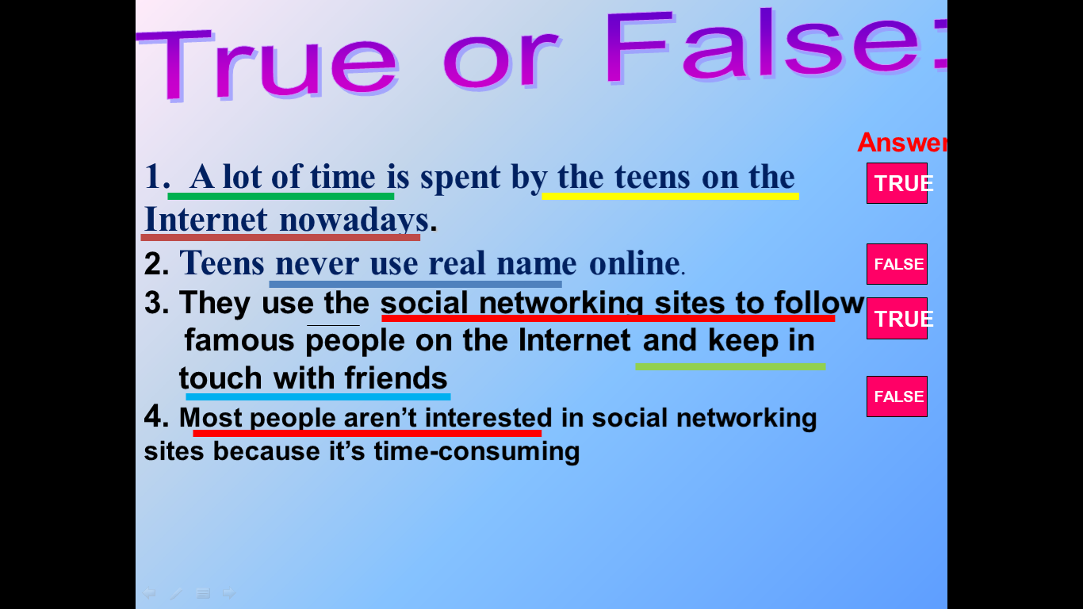

**II. Homework**

***1.Learnt new words by heart***

***2. Read the text again.***

***3. Prepare for the next lesson.***